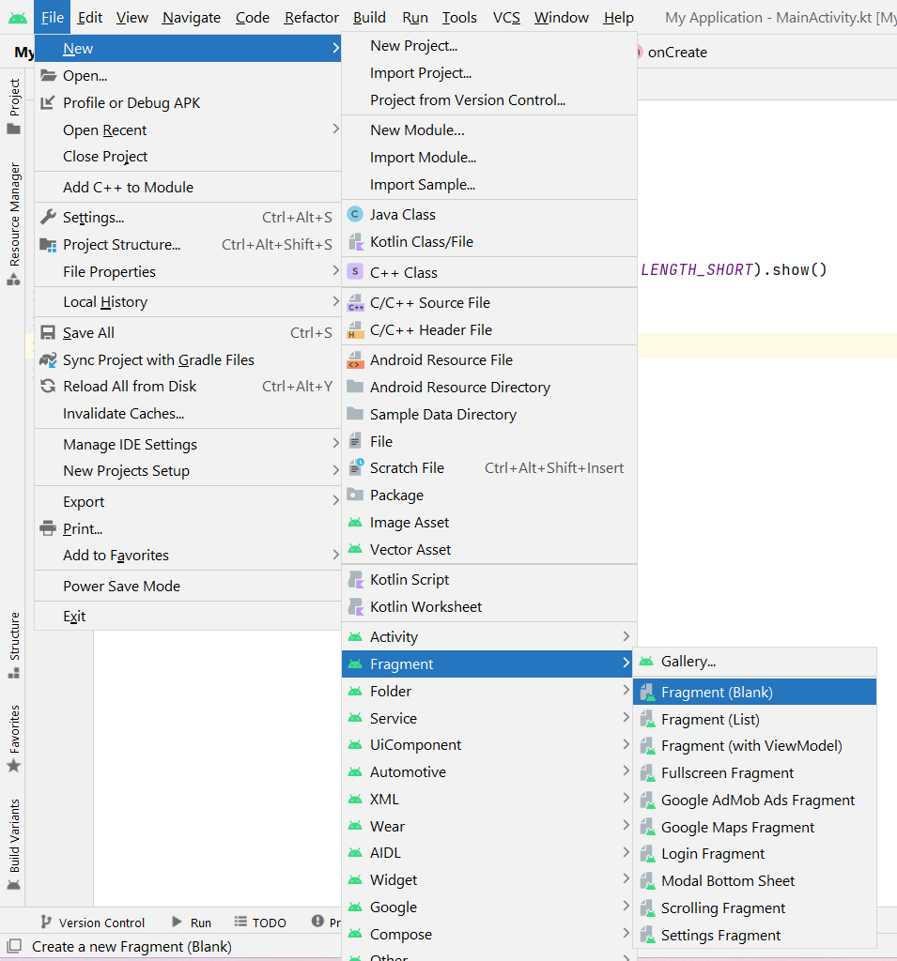
- Put name as it is (BlankFragment)
- Paste all code in create fragment
- package srm.it.myapplication
import android.content.Context
import android.os.Bundle
import androidx.fragment.app.Fragment
import android.view.LayoutInflater
import android.view.View
import android.view.ViewGroup
import android.widget.Toast
class BlankFragment : Fragment() {
override fun onCreate(savedInstanceState: Bundle?) {
Toast.makeText(context,"on Create",Toast.LENGTH_SHORT).show()
super.onCreate(savedInstanceState)
}
override fun onCreateView(
inflater: LayoutInflater, container: ViewGroup?,
savedInstanceState: Bundle?
): View? {
return inflater.inflate(R.layout.fragment_blank, container, false)
}
override fun onStart() {
Toast.makeText(context,"on start",Toast.LENGTH_SHORT).show()
super.onStart()
}
override fun onPause() {
Toast.makeText(context,"on pause",Toast.LENGTH_SHORT).show()
super.onPause()
}
override fun onResume() {
Toast.makeText(context,"on resume",Toast.LENGTH_SHORT).show()
super.onResume()
}
override fun onStop() {
Toast.makeText(context,"on stop",Toast.LENGTH_SHORT).show()
super.onStop()
}
override fun onDestroy() {
Toast.makeText(context,"on destroy",Toast.LENGTH_SHORT).show()
super.onDestroy()
}
override fun onAttach(context: Context) {
Toast.makeText(context,"on attach",Toast.LENGTH_SHORT).show()
super.onAttach(context)
}
override fun onDetach() {
Toast.makeText(context,"on detach",Toast.LENGTH_SHORT).show()
super.onDetach()
}
}

- go to fragment code session

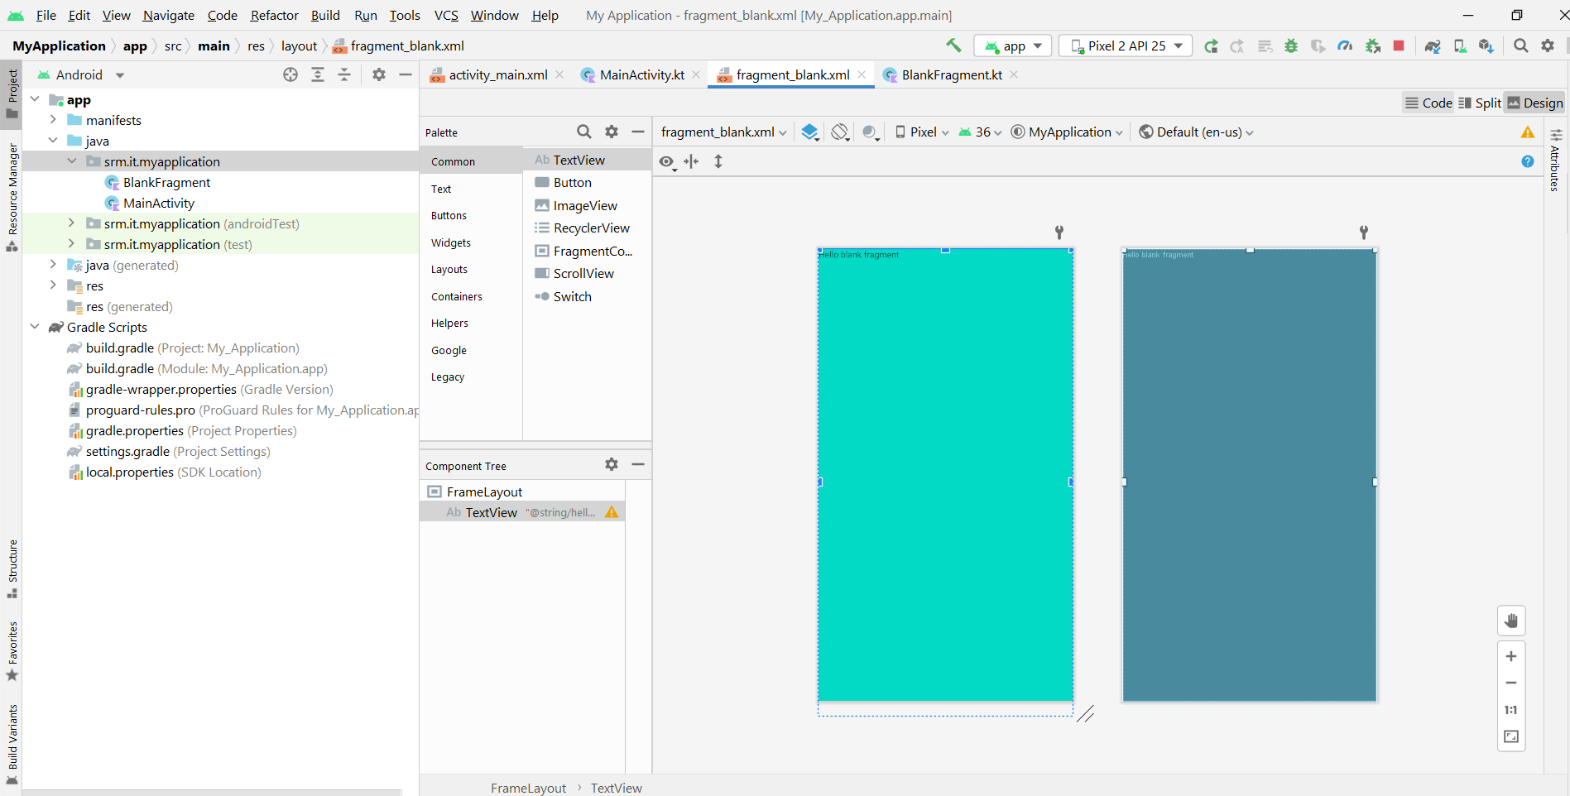
And add background color
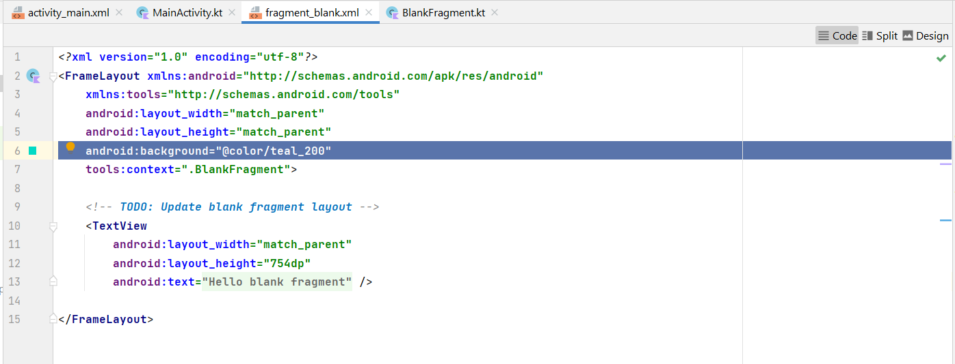
- go to mainactivity and add fragment container
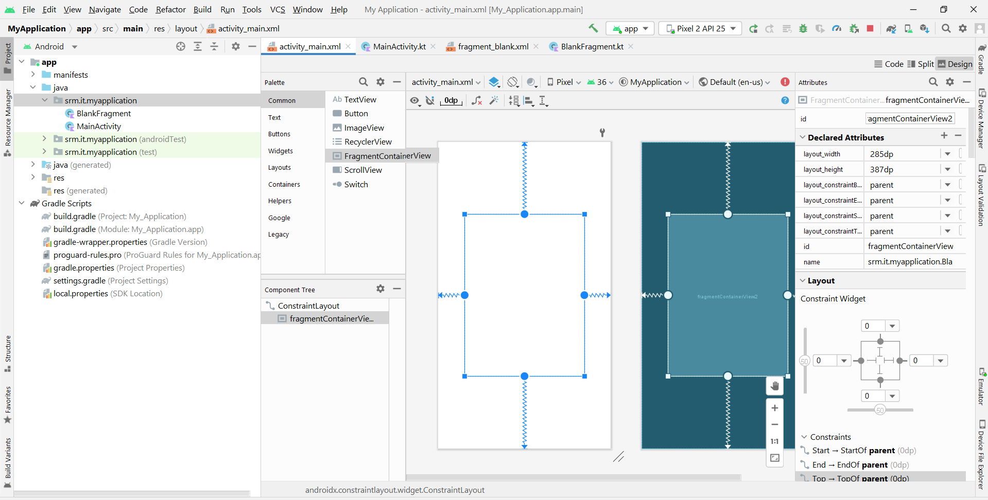
- select the name that you give for fragment and ok

